Ideation Phase

Define Problem Statements

|  |  |
| --- | --- |
| Date | 31 October 2022 |
| Team ID | PNT2022TMID22872 |
| Project Name | Real-time river water quality monitoring and control system |
| Maximum Marks | 2 Marks |

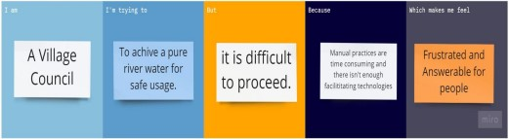

|  |  |  |  |  |  |
| --- | --- | --- | --- | --- | --- |
| Problem  Statement  (PS) | I am  (Customer) | I’m trying to | But | Because | Which makes  me feel |
| PS-1 | Villager  who  suffer from impure water issues. | I’m trying to take an  initiative of purifying river water that prevent major and minor health issues to cattle. | But I can’t achieve because I can’t find proper method to purify than  manual  practice or can’t find an apt product. | Because  of poisonous state of water we are unable to use it. It creates major and minor health issues to all the villagers. | It makes  me  frustrated and makes me answerable  for the health and risk factors that the villagers take. |
| PS-2 | Farmer. | I’m growing food crops and Forage crops. | But often get disappointed due to chemical imbalance and contaminations in the water Supply from river. | Use of good water and fertilizers  itself  produce necessary growth in crops. The untreated river water creates decay of crops and affects production. | It makes me to feel like all my works are vain. I will become clueless about my Farming techniques and survival. |